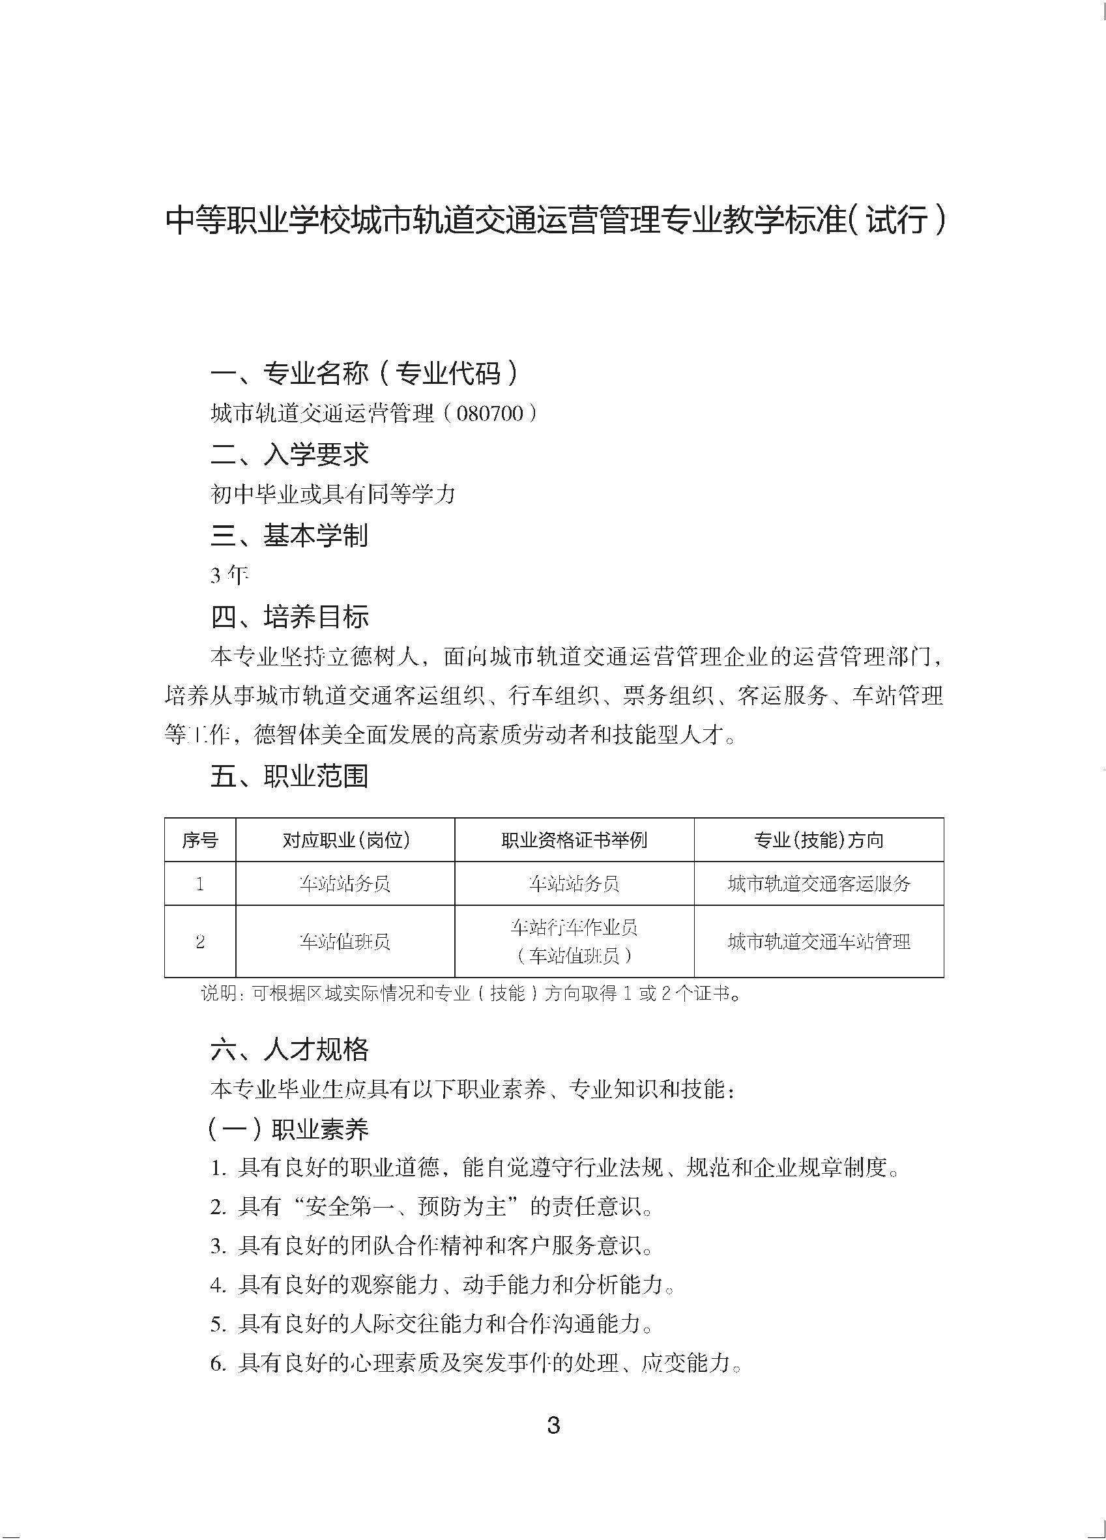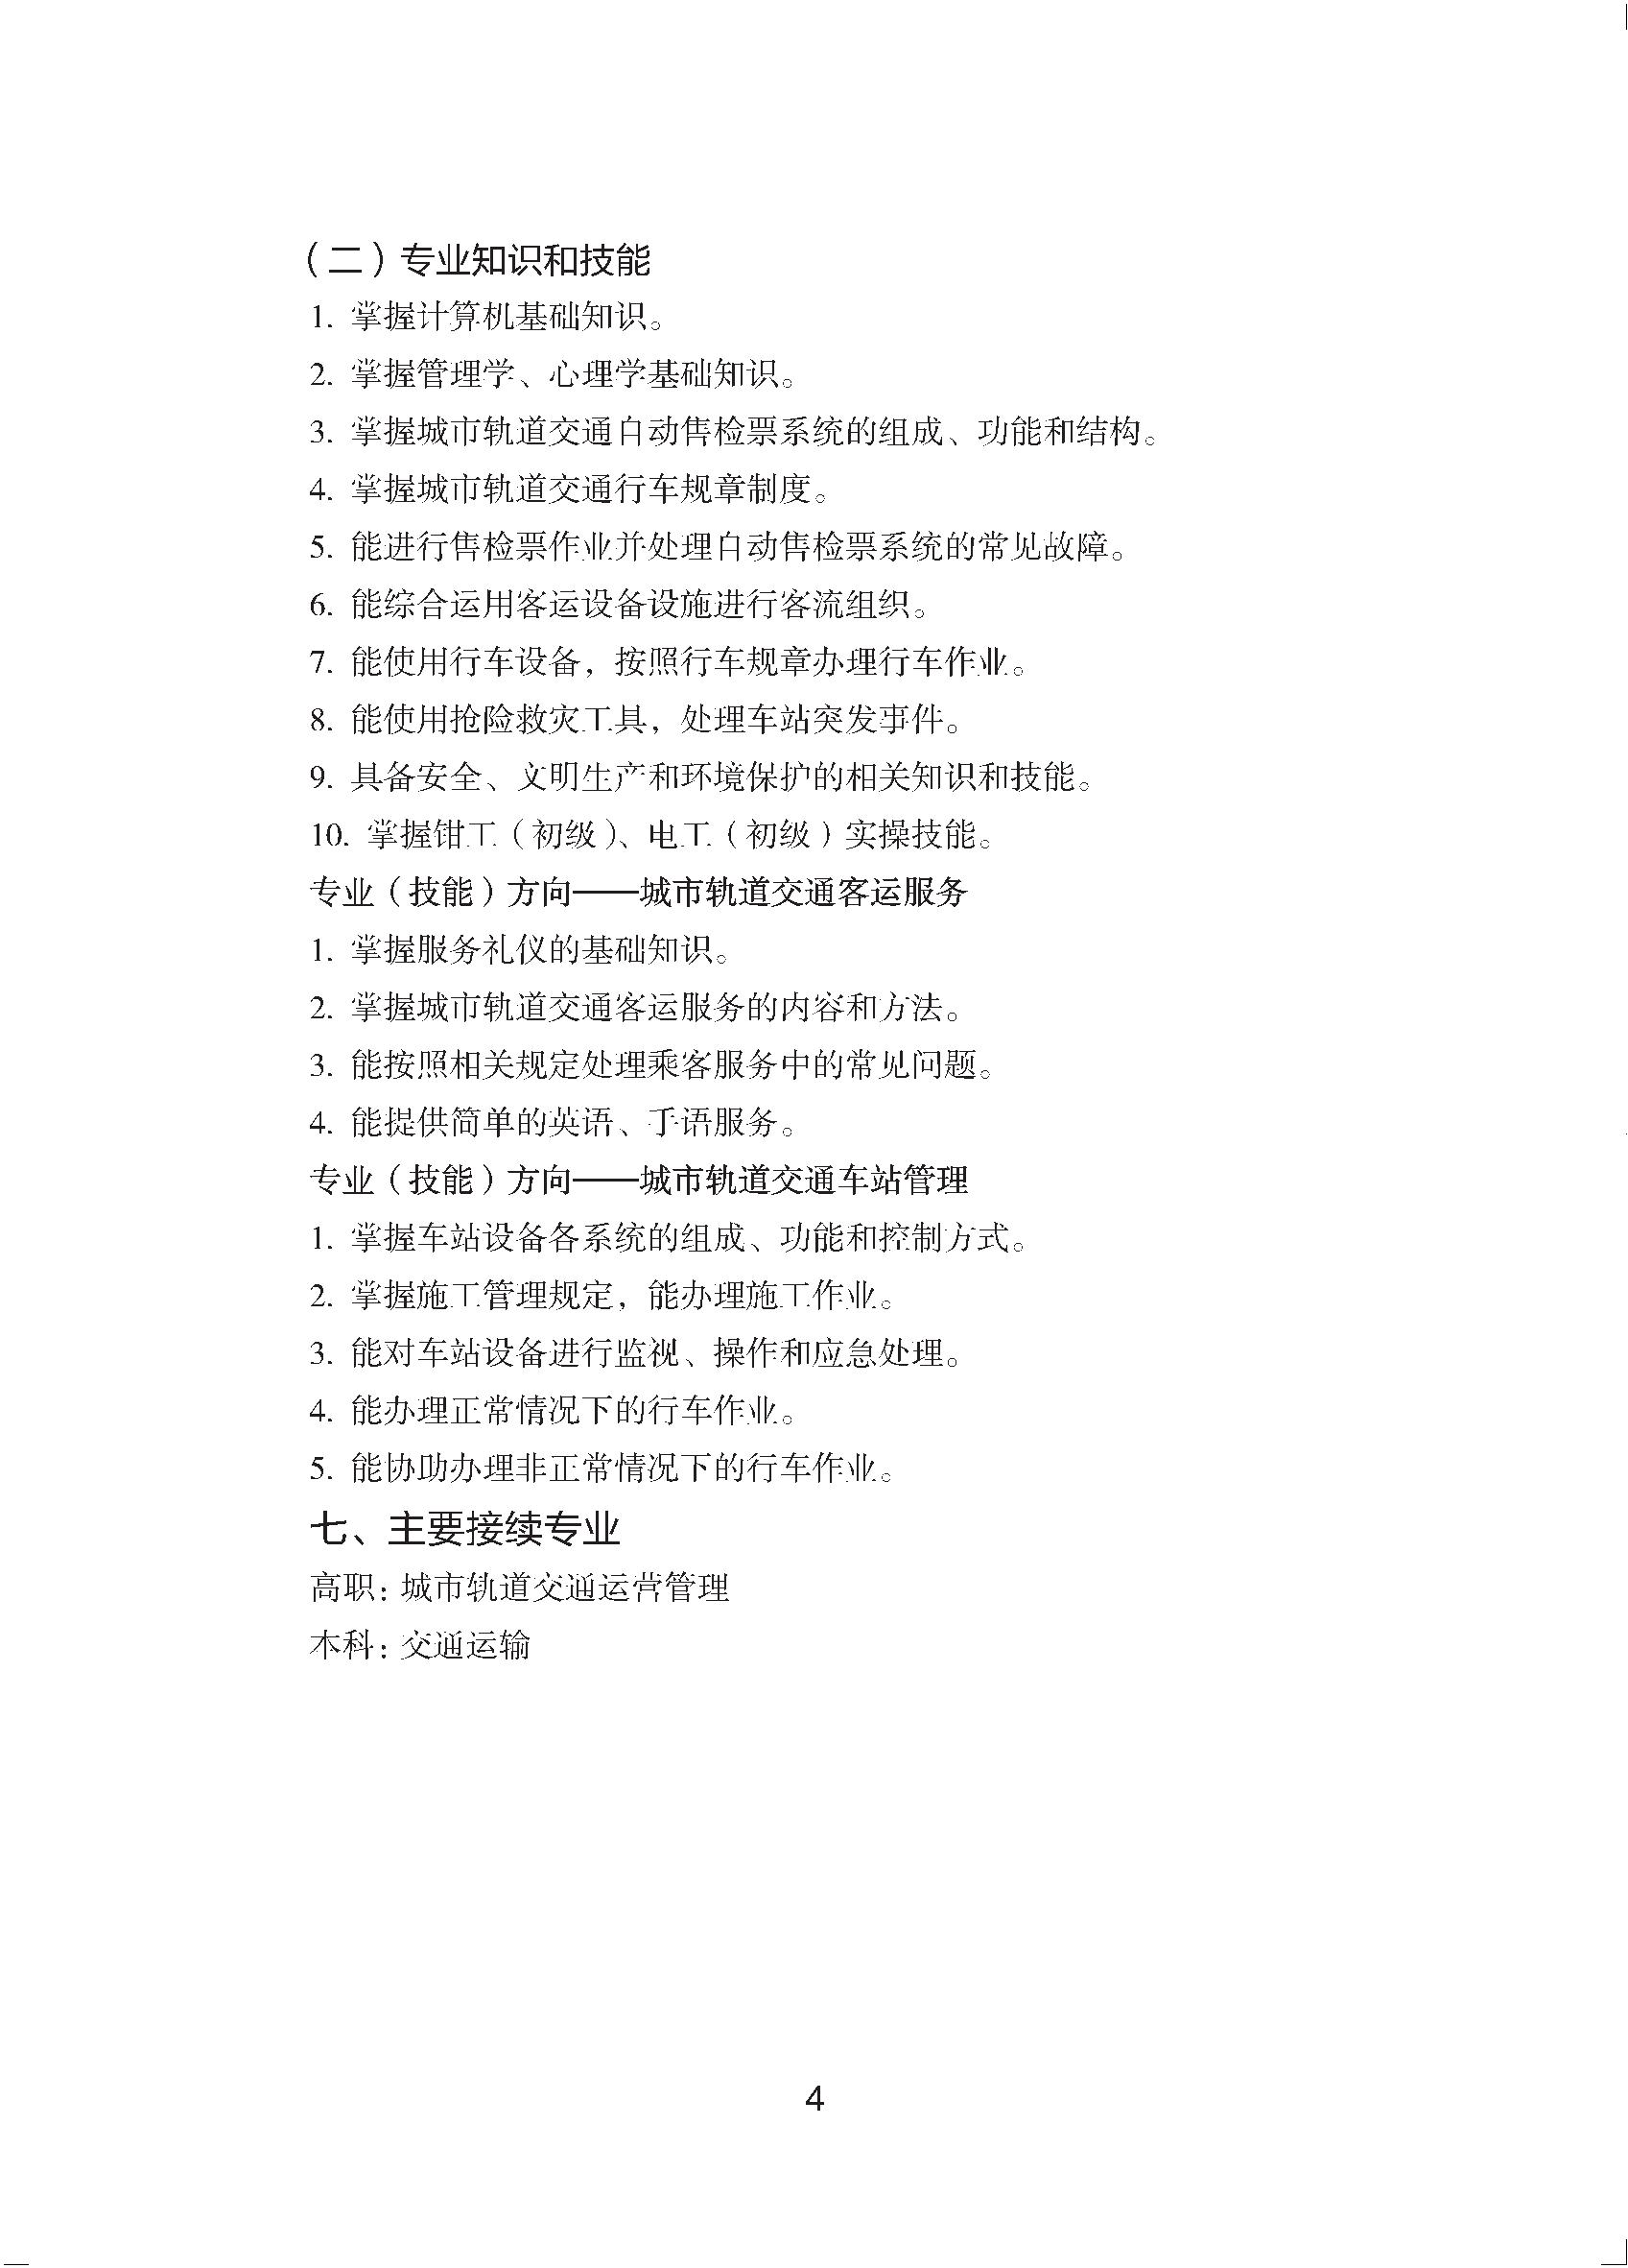

䶣ᇄ჋΍

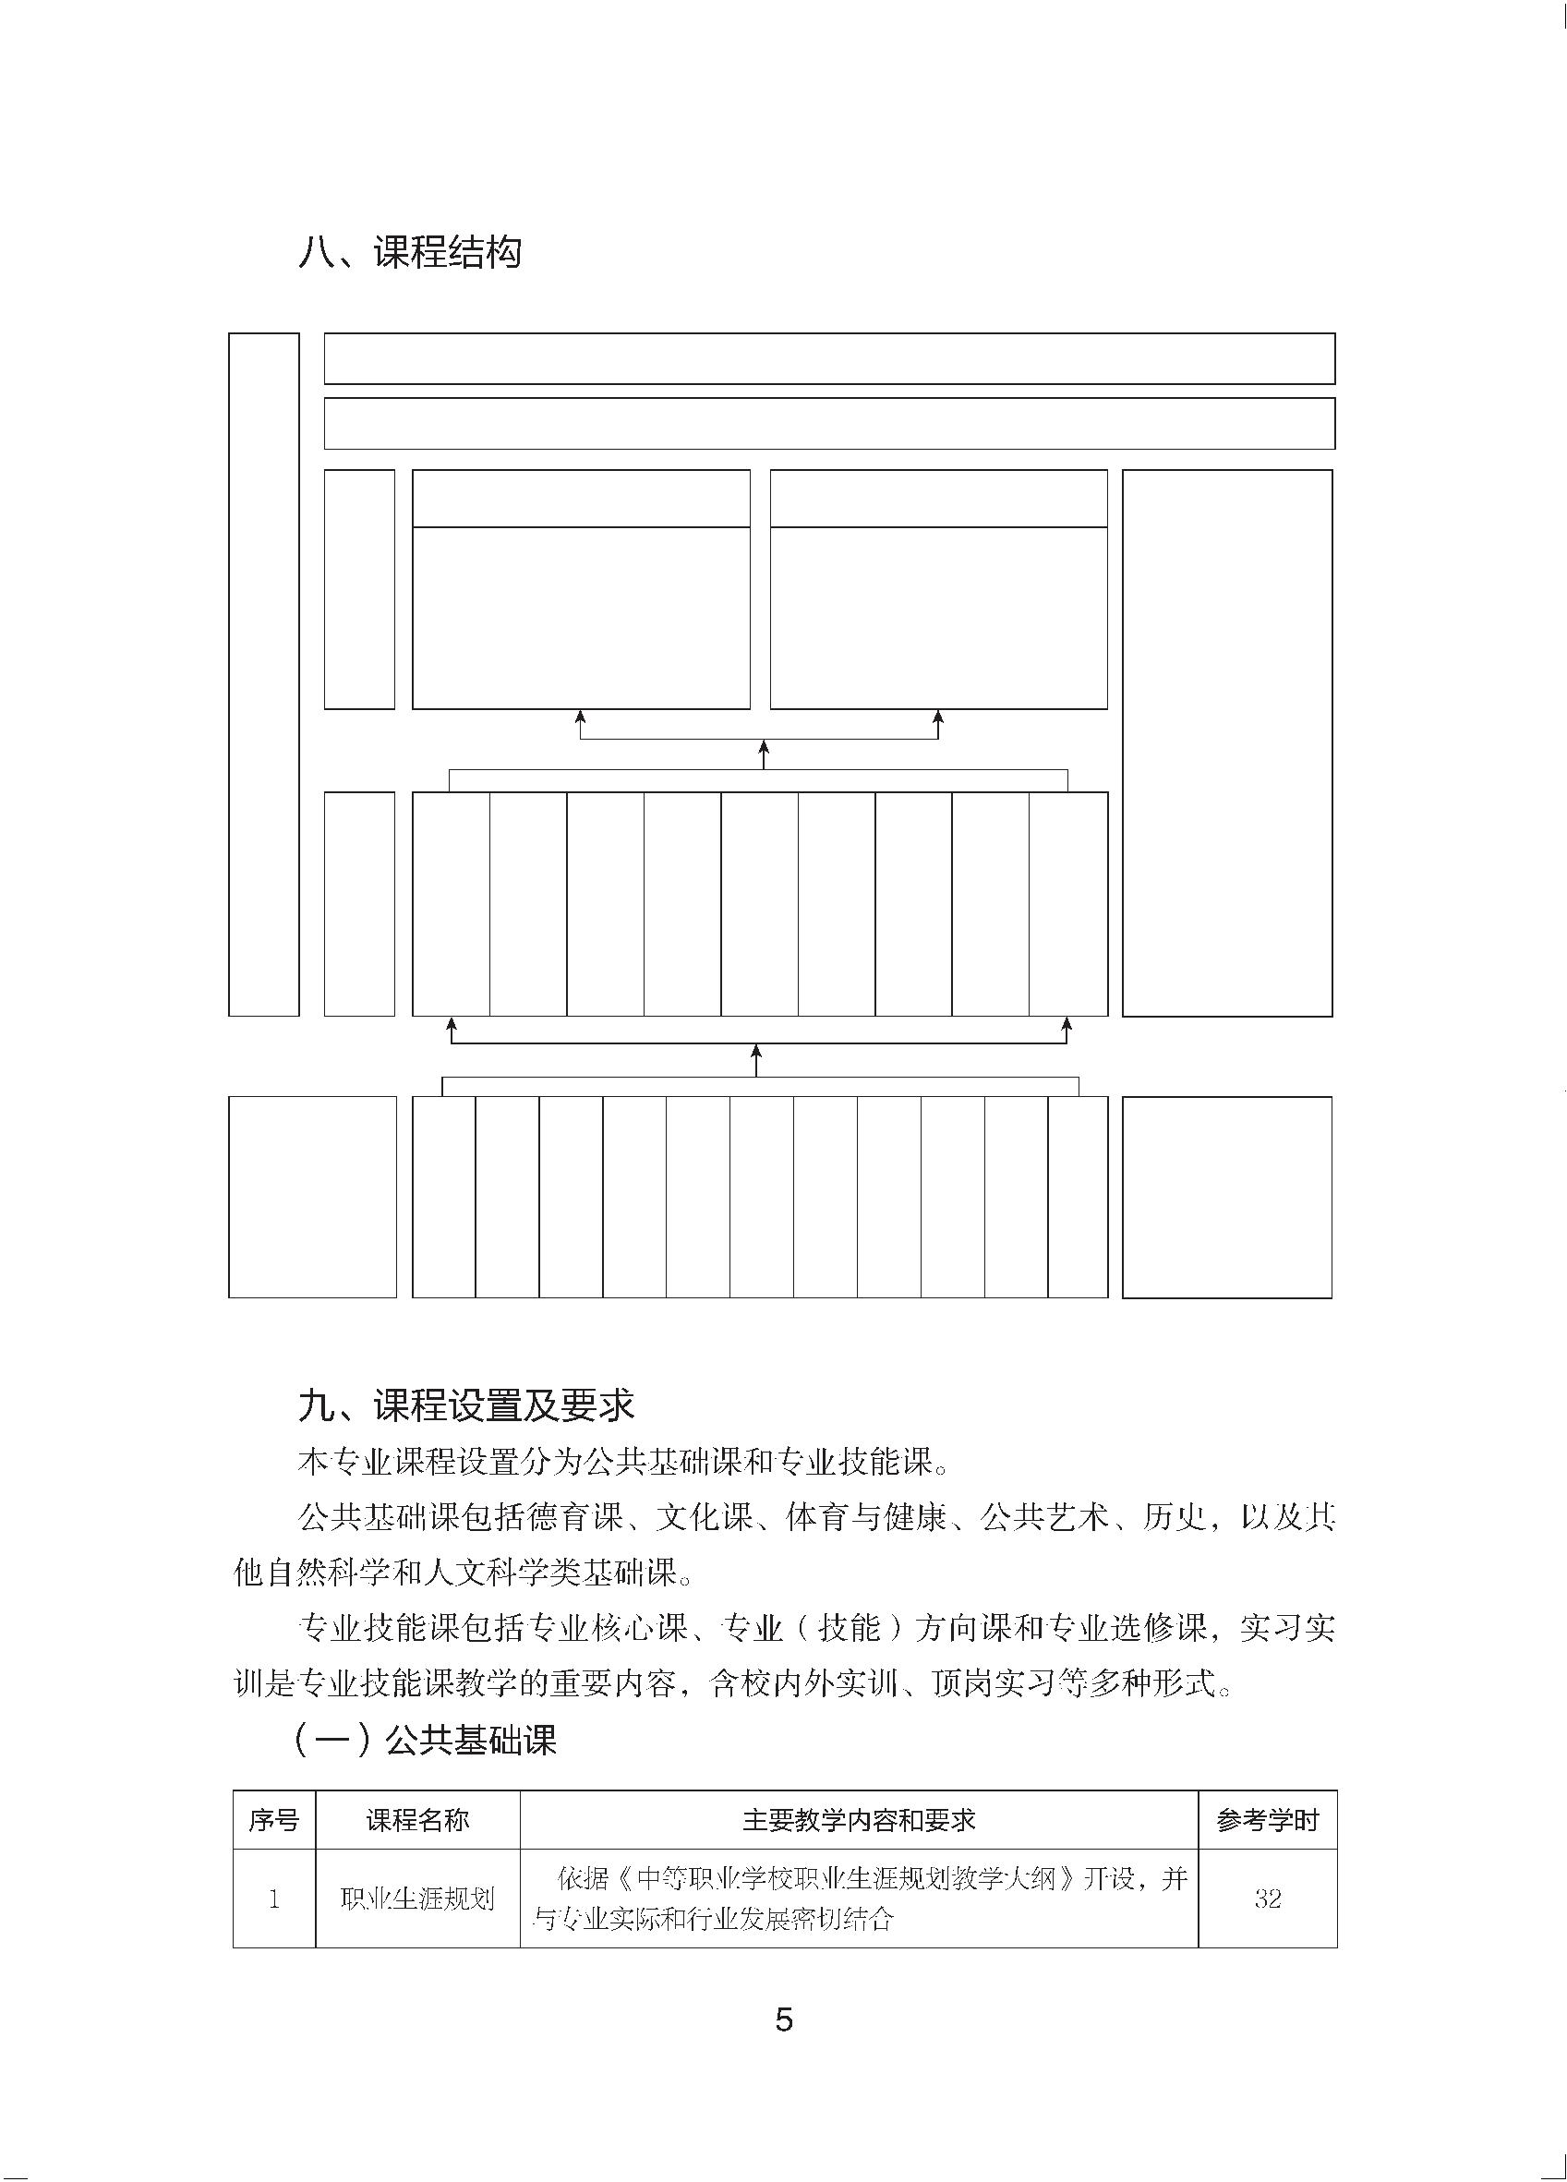

㐩व჋䃚

|  |  |  |  |  |  |  |  |  |  |
| --- | --- | --- | --- | --- | --- | --- | --- | --- | --- |
|  | ̀  ͇  ឭ  㘪  䄫 |  | ̀  ͇  啖  ឭ  㘪  啗  ᫦  ा  䄫 |  | ೻ጯ䒕䖀ϑ䕇჏䓽᰺ߎ᫦ा  䒓〆᰺ߎ̻ែ䃶ั⤳ |  |  |  | ڣЃ |
|  | ̀  ͇  ᵥ  ᓰ  䄫 |  | ᱧᷝ  ፥䃳  ̻䧠  ጒ჋  䃚 |  | ⩢ጒ  ⩢ၽ  ឭᱜ  ̻ឭ  㘪 |  | ೻ጯ  䒕䖀  ϑ䕇  䓽㥒  ノ⤳ |  | ೻ጯ  䒕䖀  ϑ䕇  䒓〆  䃫ิ |  | ೻ጯ  䒕䖀  ϑ䕇  㜗ߕ  ਜ਼ᷭ  ⺕჋  ߎ |  | 㵹䒓  ㏱㏴  ധ⵭ |  | ೻ጯ  䒕䖀  ϑ䕇  ჏䓽  ㏱㏴ |  | ೻ጯ  䒕䖀  ϑ䕇  ⾮ࣾ  θУ  Ꮑᕒ  ั⤳ |  | ೻ጯ  䒕䖀  ϑ䕇  䓽㥒  Ⴖڕ |
| ڞڙ  ധ⵭䄫 |  | 㕹  ͇  ⩌  ⋜  㻱  ܿ |  | 㕹  ͇  䖀  ᓤ  ̻  ∂  ᒸ |  | ㏼  ≻  ᩬ  ⇨  ̻  ⹫  ч |  | ਟ  ႓  ̻  ϧ  ⩌ |  | 䄚  ᪴ |  | ᪝  ႓ |  | 㠞  䄚 |  | 䃎  ツ  ᱧ  Ꮑ  ⩕  ധ  ⵭ |  | Ҁ  㗟  ̻  ֒  Ꮴ |  | ڙ  ڞ  㞧  ᱜ |  | ࢳ  ट |  | ڞڙ䔶ԛ䄫  ᓰ⤳֒Ꮴ |

